HARSHVARDHAN  TRIPATHI  Mobile No: 8957949583  Email- harshavardhan.tripathi.1234@gmail.co m  LinkedIn ID- https://www.linkedin.com/in/harsh-tripathi8957/  GitHub- https://github.com/Harsh89579 | 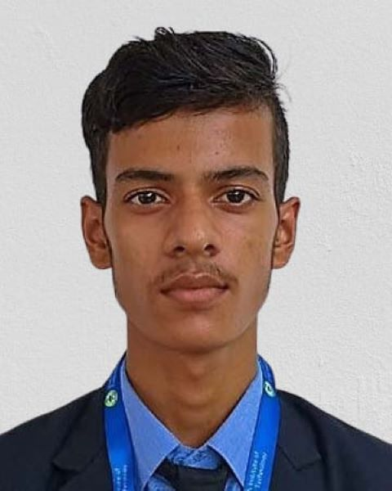
Objective
As a final-year of B.Tech. student with a strong interest in Data Analytics, equipped with foundational knowledge in Python, SQL, and data visualization tools like Excel and Power BI. Eager to apply analytical and problem-solving skills in a dynamic environment to support data-driven decision-making and gain hands-on industry experience.
Education
Qualification | Board/University | Institution Name | Year of Passing | Percentage Secured
B.Tech (Bachelo r o f Technology) | Dr. APJ Abdul Kalam Technical University | Shambhunath Institute of  Engineering and Technology | (pursuing)
Intermediate | (U.P.) Board | Hindu Inter college | 2022 | 70%
High School | (U.P.) Bo ard | BNPN Inter college | 2020 | 76.66%

Internship or Experience
Codsoft
October 2024 – November 2024 | Remote Internship – Web Development
- Gained practical knowledge of HTML, CSS, Javascript.
- Built personal portfolio website and web based calculator.

Technical Skills
- Languages: Python, SQL
- Tools: Visual Studio code, Power BI, Git/GitHub
- Core Areas: Data Analytics, Frontend Development
Professional Skills
- Strong Communication & Collaboration
- Problem-Solving & Logical Thinking
- Time Management & Teamwork
- Adaptability & Continuous Learning

